DDL Understanding

Why Foreign Keys Are Used
Foreign keys are used to maintain referential integrity between tables in a database.
In the given schema, the user_id in the expenses table is a foreign key that references user_id in the users table.
This means:
- Every expense must belong to a valid user.
- The database prevents inserting an expense for a user that does not exist.
Example:
If users table contains:
user_id | name
1 | Rahul
Then the following expense is valid:
expense_id | user_id | amount
101 | 1 | 500
But this is invalid:
expense_id | user_id | amount
102 | 99 | 700
because user 99 does not exist in the users table.
So, foreign keys help:
- Maintain data accuracy
- Prevent invalid relationships
- Keep tables connected properly

Issue if Foreign Keys Were Removed (Orphaned Records)
If foreign keys are removed, the database would allow orphaned records.
An orphaned record means:
- An expense exists for a user that no longer exists in the users table.
Example:
Suppose this expense exists:
expense_id | user_id | amount
201 | 5 | 1200
Later, user 5 is deleted from the users table.
Without foreign keys:
- The expense record would still remain.
- The database would now contain an expense linked to a non-existent user.
Problems caused:
- Incorrect reports
- Data inconsistency
- Difficulty tracking ownership of expenses
- Invalid database relationships
Therefore, foreign keys are important for keeping the database reliable and consistent.

2. DML Operations Write SQL queries to:
● Insert 5 users into the users table with unique names and emails.
● Insert 3 categories (e.g., 'Food', 'Rent', 'Entertainment').
● Insert 10 expense records distributed across different users and categories.
● Update one incorrect expense: Use the UPDATE command to change the amount of a specific expense_id.
● Delete one expense: Remove a record where the amount is less than a specific value.

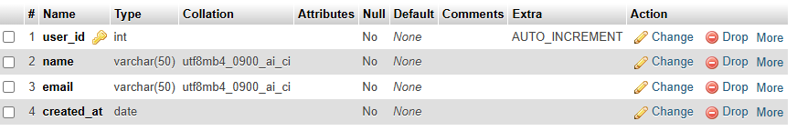
INSERT INTO users (user_id, name, email, created_at)
VALUES
(1, 'Rahul', 'rahul@gmail.com', '2026-05-01'),
(2, 'Priya', 'priya@gmail.com', '2026-05-02'),
(3, 'Amit', 'amit@gmail.com', '2026-05-03'),
(4, 'Sneha', 'sneha@gmail.com', '2026-05-04'),
(5, 'Karan', 'karan@gmail.com', '2026-05-05');
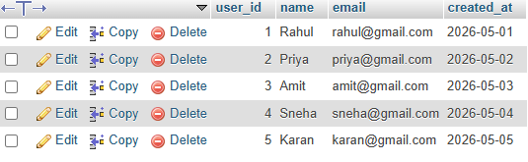
CREATE TABLE categories (
category_id INT PRIMARY KEY,
category_name VARCHAR(50)
);
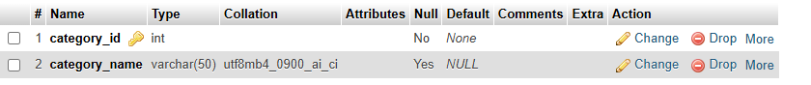

INSERT INTO categories (category_id, category_name)
VALUES
(1, 'Food'),
(2, 'Rent'),
(3, 'Entertainment');

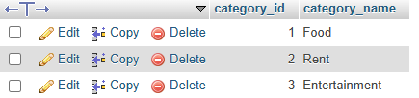

CREATE TABLE expenses (
expense_id INT PRIMARY KEY,
user_id INT,
category_id INT,
amount DECIMAL(10,2),
expense_date DATE,
FOREIGN KEY (user_id) REFERENCES users(user_id),
FOREIGN KEY (category_id) REFERENCES categories(category_id)
);
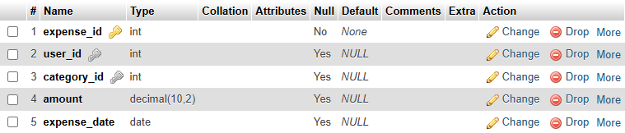
INSERT INTO expenses (expense_id, user_id, category_id, amount, expense_date)
VALUES
(1, 1, 1, 500.00, '2026-05-10'),
(2, 1, 2, 3000.00, '2026-05-11'),
(3, 2, 1, 250.00, '2026-05-12'),
(4, 2, 3, 700.00, '2026-05-13'),
(5, 3, 2, 4000.00, '2026-05-14'),
(6, 3, 1, 350.00, '2026-05-15'),
(7, 4, 3, 900.00, '2026-05-16'),
(8, 4, 1, 450.00, '2026-05-17'),
(9, 5, 2, 5000.00, '2026-05-18'),
(10, 5, 3, 1200.00, '2026-05-19');
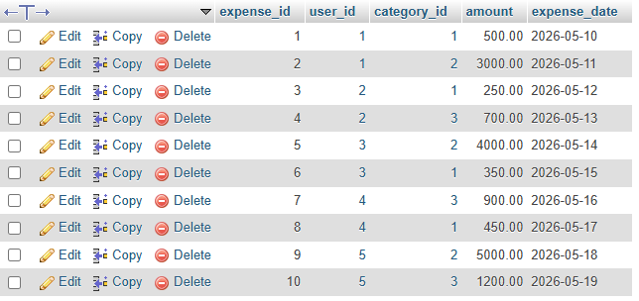
UPDATE expenses
SET amount = 800.00
WHERE expense_id = 4;

DELETE FROM expenses
WHERE amount < 300;
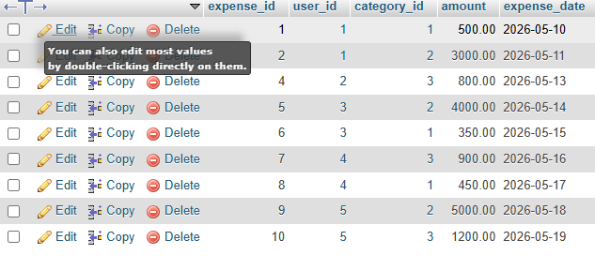

3. Data Retrieval
1. Display All Expenses with Details (Using INNER JOIN)
SELECT
e.expense_date,
e.amount,
u.name,
c.category_name
FROM expenses e
INNER JOIN users u
ON e.user_id = u.user_id
INNER JOIN categories c
ON e.category_id = c.category_id;

Explanation
- INNER JOIN users connects expenses with users.
- INNER JOIN categories connects expenses with categories.
- Displays:
  - Expense date
  - Amount
  - User name
  - Category name

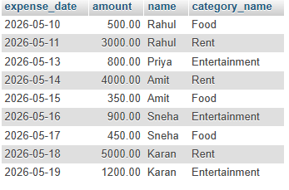

2. Show Total Expense Amount per Category
SELECT
c.category_name,
SUM(e.amount) AS total_expense
FROM expenses e
INNER JOIN categories c
ON e.category_id = c.category_id
GROUP BY c.category_name;

Explanation
- SUM(amount) calculates total expenses.
- GROUP BY category_name groups data category-wise.

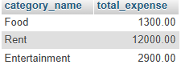

3. Display Users Sorted by Total Spending
SELECT
u.name,
SUM(e.amount) AS total_spending
FROM users u
INNER JOIN expenses e
ON u.user_id = e.user_id
GROUP BY u.name
ORDER BY total_spending DESC;

Explanation
- Calculates total spending for each user.
- ORDER BY total_spending DESC sorts from highest to lowest spending.
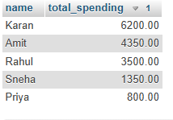
4. Views
Create a View: ActiveUsersView
CREATE VIEW ActiveUsersView AS
SELECT
u.name,
u.email
FROM users u
INNER JOIN expenses e
ON u.user_id = e.user_id
GROUP BY u.user_id, u.name, u.email
HAVING COUNT(e.expense_id) > 5;

Explanation
- INNER JOIN connects users and expenses tables.
- COUNT(e.expense_id) counts total expense records for each user.
- HAVING COUNT(...) > 5 filters users who have more than 5 expenses.
- The view stores:
  - User name
  - User email

Query the View
SELECT *
FROM ActiveUsersView;

Explanation
This statement displays all records stored in the ActiveUsersView.
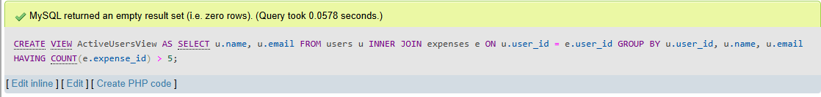
Top of Form

Bottom of Form

